CATERERS
(Estimate Only)

Welcome drinks
- Soft drinks
- Packaged water
Mocktails
- Lychee coconut
- Strawberry Diana
- Blue carasso
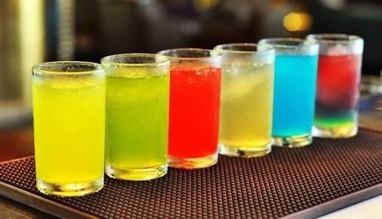
- Mojito ( flavoured)
Starters:
Veg.: ( any 2)
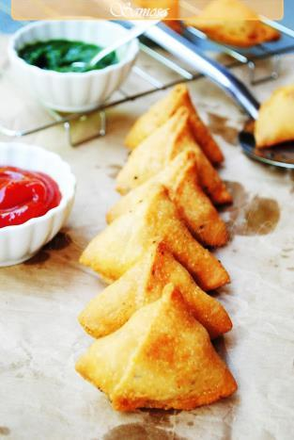
- Cheese pops
- Veg. balls in hunan sauce
- Paneer thail basil
- Paneer hunan dry
- Golden fried crispy baby corn with tartar sauce
- Hash brown alootikki + cheese + sauce
- Baby samosa
- Veg. spring roll
- Paneer malai tikka
- Potato Lemon Grass
- Veg. Sathey
- Veg. momos
- Stuffed mushroom with cheese and herbs
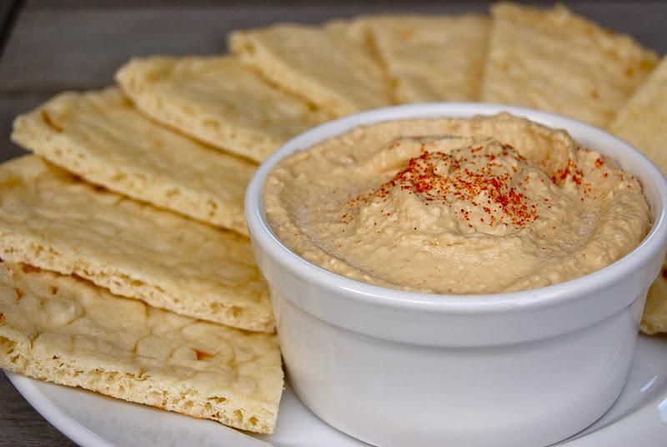
- Pita bread with humus
Non. - veg.( any 2 )

- Fish ajwani tikka
- Fish Koliwada with curd and mint chutney
- Fishphillet + tartar sauce
- Ch. Kebab in mustard sauce with stuffed cheese
- Ch. Kandhari kebab
- Ch. Finger
- Ch. Malai garlic kebab
- Ch. Tikka
- Ch. Pepperblast
- Ch. Korean sathey
- Ch. Honey garlic
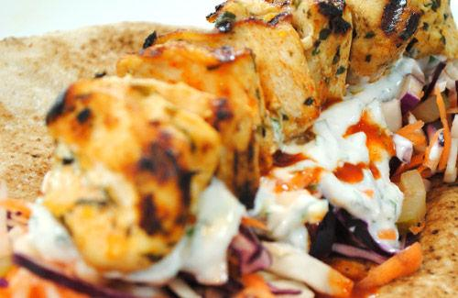
- Ch. With lemongrass

Live counters
( any 2 )

Khousey counter:
- Khousey with mushroom babycorn and broccoli along with rice and noodles

Condonments :
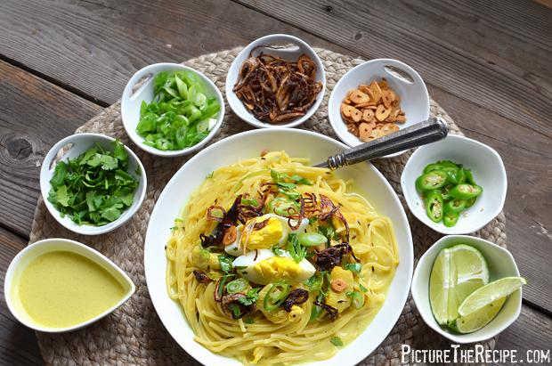
- Peanuts fried garlic
- Fried onion
- Spring onions
- Pudina
- Lemon wedges
- Fried noodles
- Chilli flakes

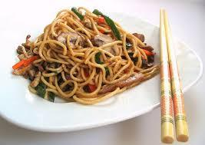
Chinese counter
- Veg. hakka noodles
- Veg. fried rice
- Veg. Balls in oyster sauce

Korean counter :
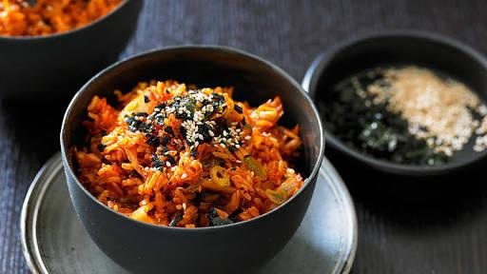
- Korean fried rice
- Korean noodles
- Exotic veggies in Korean gravy

Thai counter
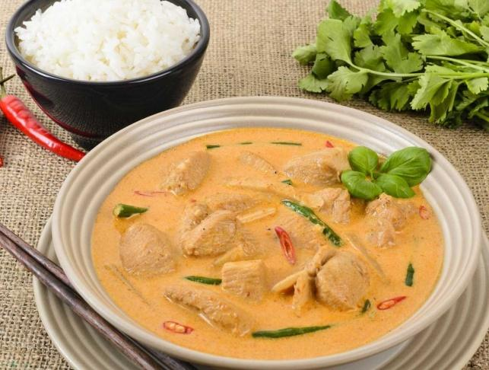
- Fish Thai red curry
- Exotic vegetables in thai green curry
- Thai spicy noodles

Chaat counter { any 2}

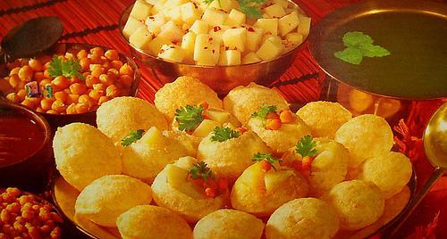
- Panipuri
- DahiPuri
- AlooTikkiChhole
- Dahi papdi chaat

Pizza counter :
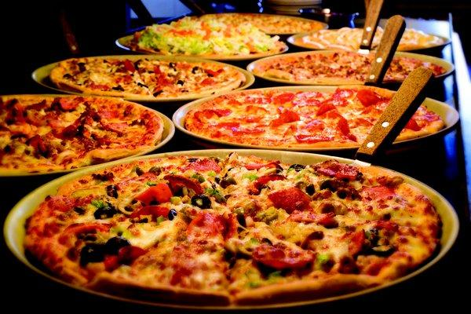
- Cheese margarita pizza
- Fresh exotic veg. garden green pizz

Pasta Conter:
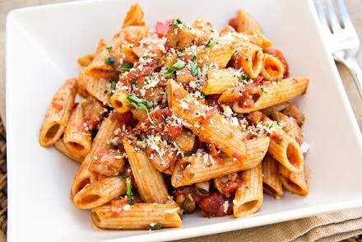
- White Cheesy Pasta
- Red Tomato Salsa Pasta
- Green Basil Pasta

Shwarma counter:
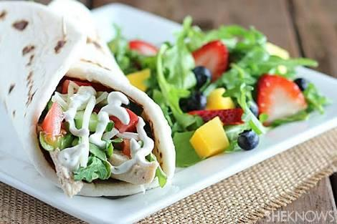
- Ch. Shwarma
- Veg. Paneer Shwarma
- Mayo garlic
- Hummus
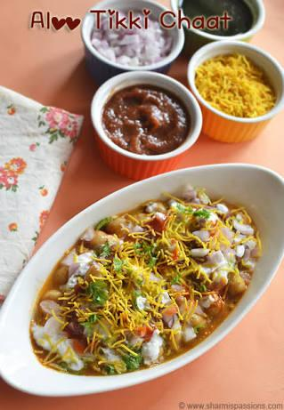
Aloo tikki counter :

- Punjabi chole
- Karari aloo tikki

Pav bhaji counter

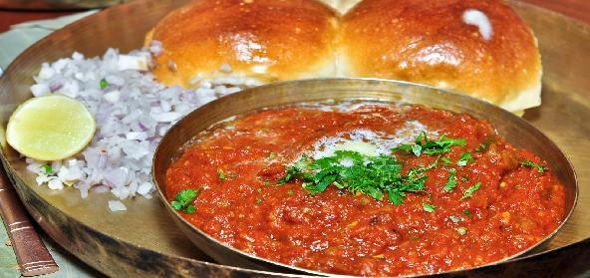
- Mumbai ki bhaji
- Butter pav

Dosa counter

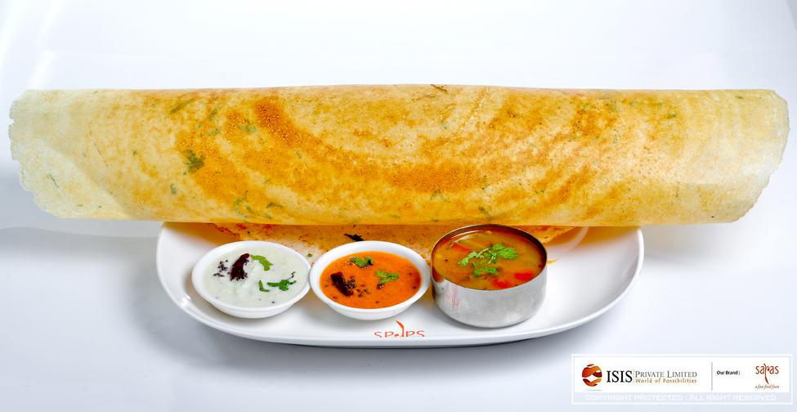
- Cheese
- Masala
- Sada
- Chinese
- Oriental

MAIN COURSE: { Indian }

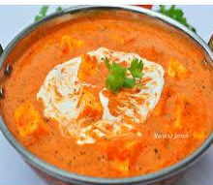
Paneer Dishes (Any 1):

- Paneer Butter masala
- PaneerKadai
- Paneer Maharaja
- PaneerLasooni

Sabjiyon ki Bahar ( any 2)

- Kofta Masala
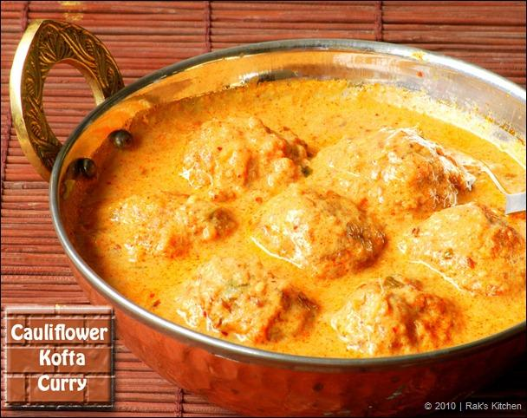
- Methi mutter masala
- Dengri Mutter Masala
- Veg. Banjara
- Veg. Jalfrezi
- Mix Veg. Begum Bahar
- Mix Veg. on tava

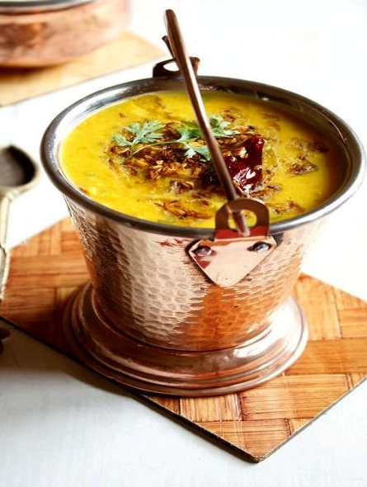
Choice of dal ( any 1)

- Dal Tadka
- Dal Makhani
- Dal Panchratni

Non - veg.:( any 2 )
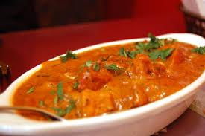
- Chicken laziz ( boneless )
- Methi Chicken
- Butter chicken
- KeemaKaleji with egg &pav
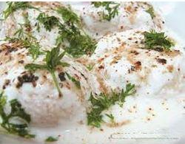
Curd (any 1):

- Small Dahiwada with mint
- DahiboondiRaita
- Pineapple Raita
- KachumberRaita
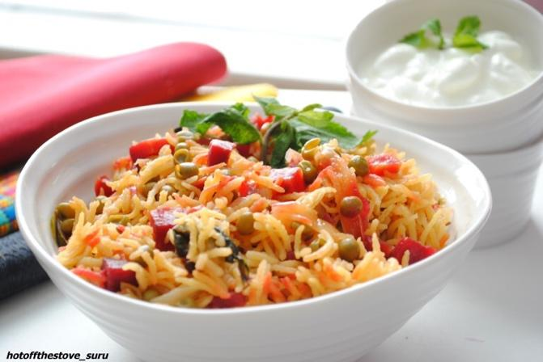
Choice of rice(any1):
- Peas Pulao
- Jeera Onion walleChhawal
- Kashmiri Pulao
- Carrot Rice

Choice of rotis:
- Roti
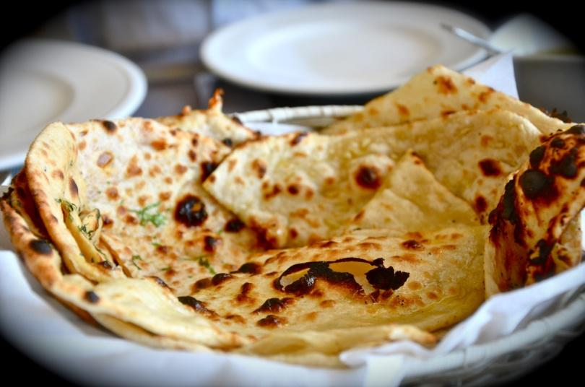
- Naan
- Paratha
- Stuffed kulchas
- Missi roti
- Makkai Ki Roti
- Paneerkulcha
- Shz. Onion Kulcha

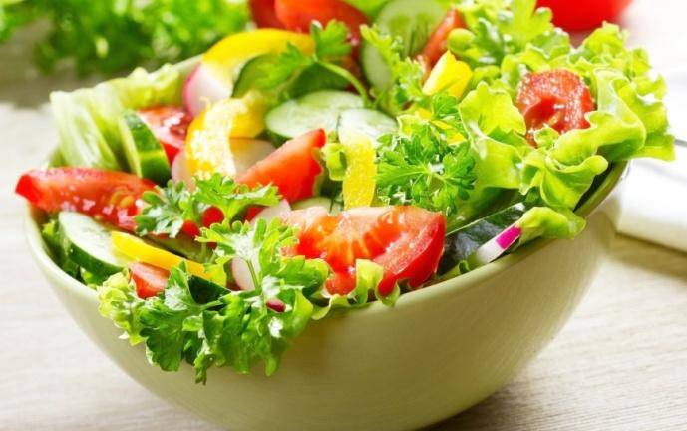
Salads :( any 3)
- Fresh garden green salad
- Pasta salad
- Veg. Tossed salad
- Sprouts in heaven
Desserts
( any 2 )
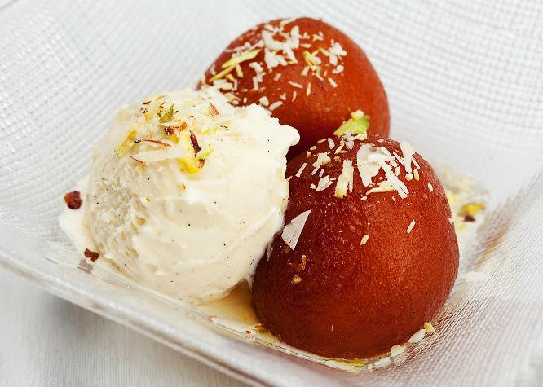
- Kulfi :
- Malai
- Kesar pista
- Gulab jamun
- Vanilla ice cream with chocolate sauce
- Chikkoo akrot Ka Halwa
- Moong dal halwa
- Gajar halwa
- Butter scotch ice creams
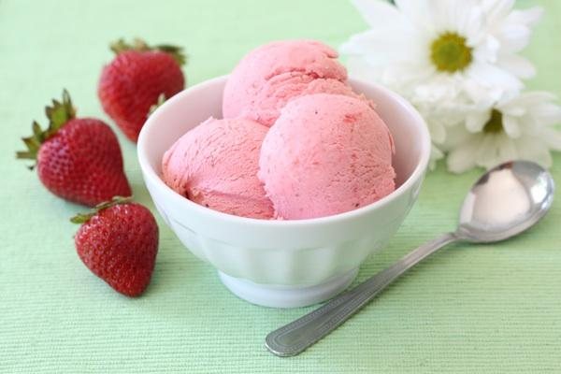
- Choice of Fresh fruit ice cream { natural }
- Strawberry
- Sitaphal
- Lavender

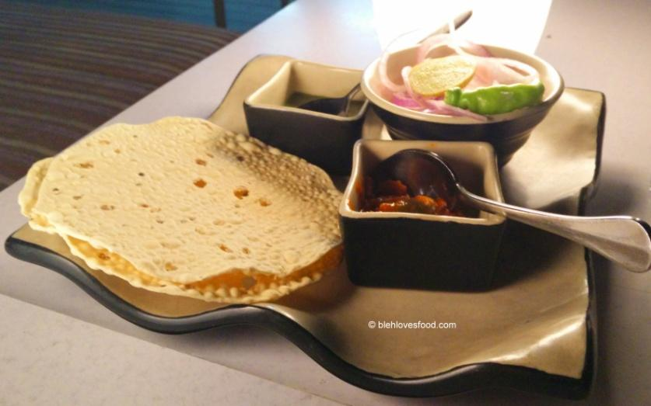
ADD – ONS…
- Papad
- Pickle
- Chutney

P.N : The aforementioned menu’s price will be discusses as per your selections .
KINDLY REVERT BACK.
P.N.: THE AFOREMENTIONED MENU IS AN ESTIMATE ONLY.PICTURES ARE ONLY FOR INDICATIVE PURPOSES.THE FINAL MENU, RATE, PAX AND OTHER ITEMS ARE TO BE DISCUSSED VIA TELEPHONIC OR ELECTRONIC MAIL MEDIUMS WITH THE PROPRIETOR OF THE FIRM.

